**Conditional Statements and Looping in Shell Script**

1. Conditional Statements: There are 5 conditional statements which can be used in bash programming
2. if statement
3. if-else statement
4. if..elif..else..fi statement (Else If ladder)
5. if..then..else..if..then..fi..fi..(Nested if)
6. switch statement

if statement

This block will process if specified condition is true.

if-else statement

If specified condition is not true in if part then else part will be executed.

if..elif..else..fi statement (Else If ladder)

To use multiple conditions in one if-else block, then elif keyword is used in shell. If expression1 is true then it executes statement 1 and 2, and this process continues. If none of the condition is true then it processes else part.

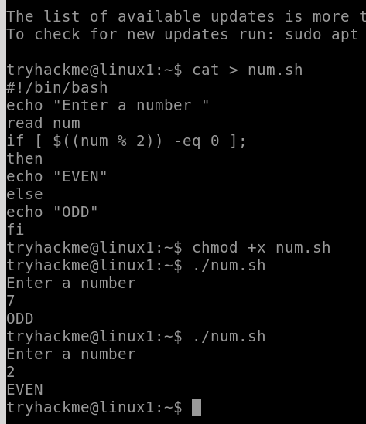

1. Looping Statements in Shell Scripting: There are total 3 looping statements that can be used in bash programming
   1. while statement:

Here the command is evaluated and based on the resulting loop will execute, if the command is raised to false then the loop will be terminated.

* 1. for statement:

The for loop operates on lists of items. It repeats a set of commands for every item in a list.

Here var is the name of a variable and word1 to word N are

sequences of characters separated by spaces (words). Each time the for loop executes, the value of the variable var is set to the next word in the list of words, word1 to word N.

* 1. until statement:

The until loop is executed as many times as the condition/command evaluates too false. The loop terminates when the

condition/command becomes true.

